Use case diagram
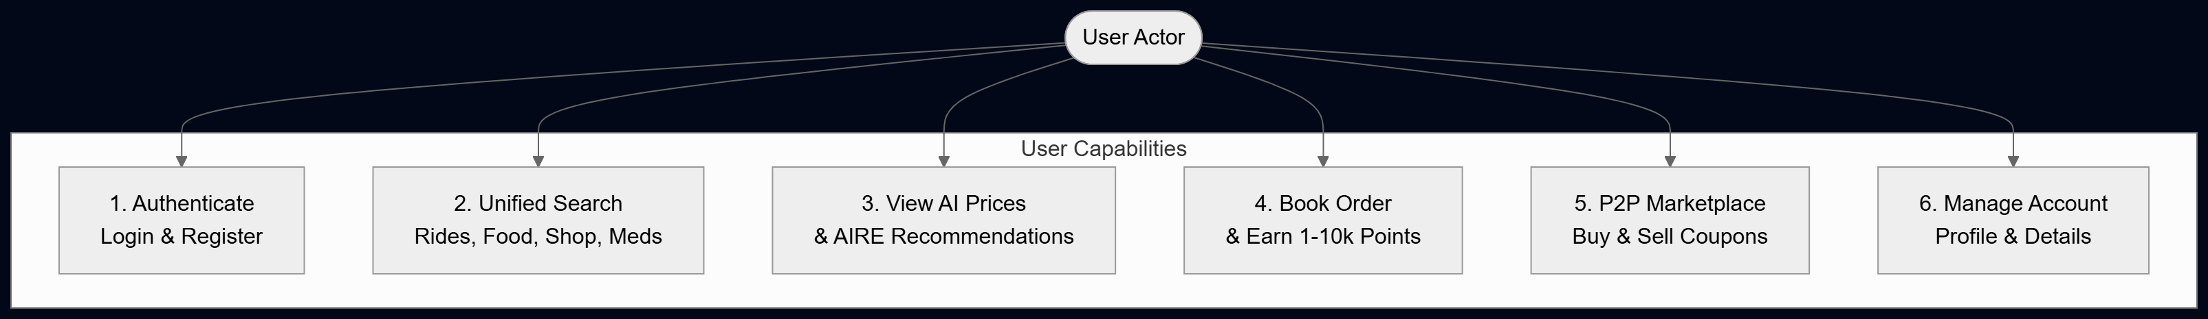
Key Flow:
- Users authenticate and submit search queries across four service domains.
- System displays predicted fares, AIRE recommendation cards, and option lists.
- Users place orders to earn random reward points receive issued coupons, and trade them on the P2P Marketplace.
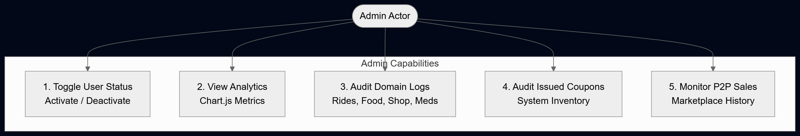
Key Flow:
- Admin manages user accounts by activating or deactivating access.
- Monitors global system health, search conversion rates, and volume via Chart.js analytics.
- Audits domain-specific order logs, system-issued coupons, and P2P marketplace transaction history.

Class diagram
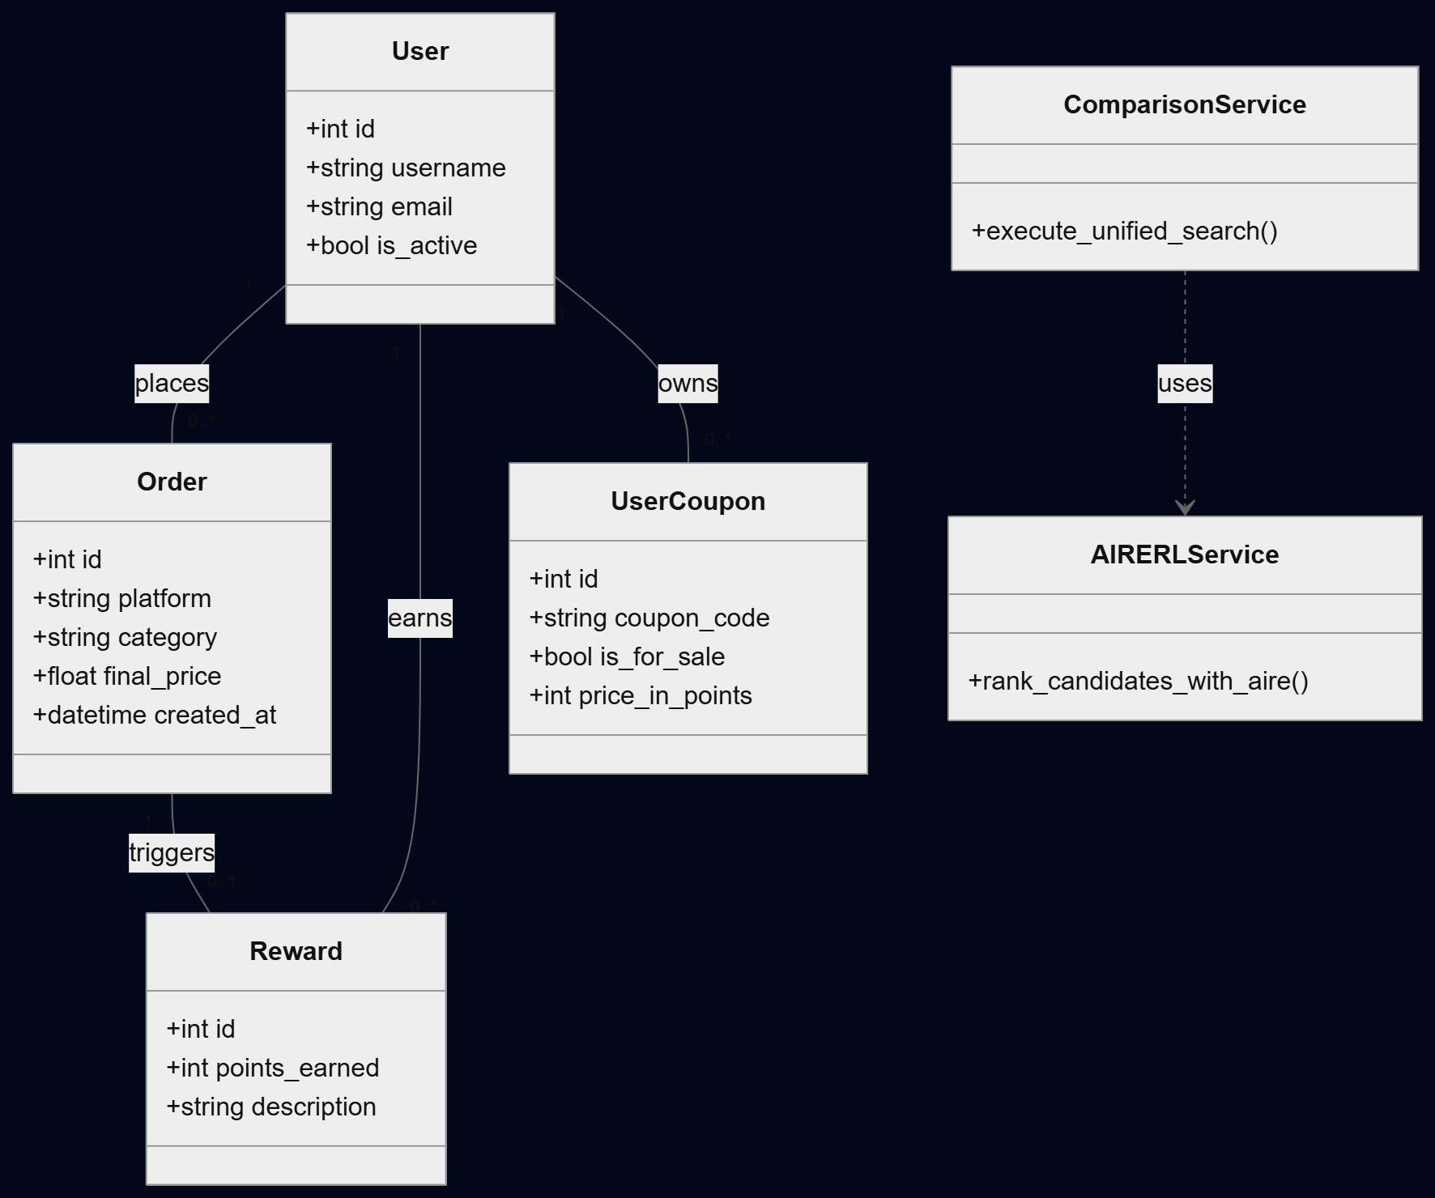
Key Flow:
- A User can place multiple Order records, earn multiple Reward point allocations, and own multiple UserCoupon items.
- An Order triggers a Reward entry and coupon assignment.
- The ComparisonService orchestrates candidate predictions and passes data to AIRERLService for scoring.

Activity diagram
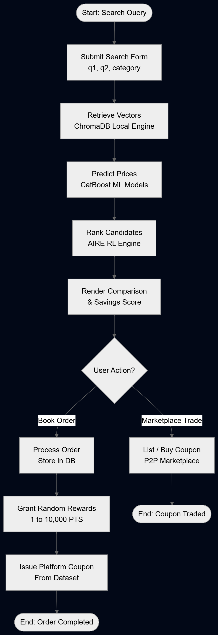
Key Flow:
- User inputs search parameters $→$ System retrieves ChromaDB vector candidates.
- CatBoost models predict prices $→$ AIRE RL Engine scores and ranks results.
- User completes booking to earn reward points and platform coupons, or visits the P2P Marketplace.
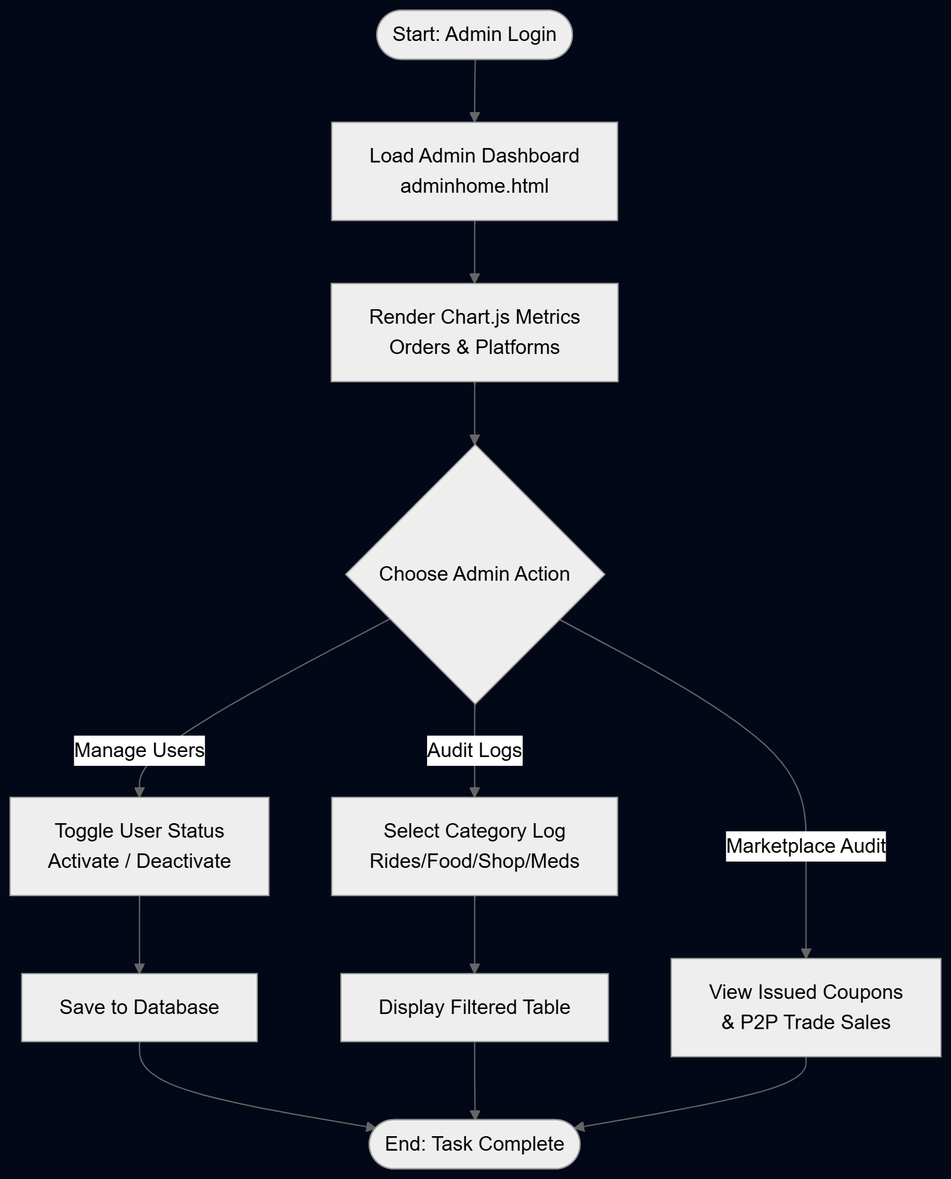
Key Flow:
- Admin authenticates and views real-time Chart.js conversion visualizers.
- Admin updates user account statuses (is_active toggle).
- Admin navigates dedicated audit logs for domain orders, issued coupons, and marketplace trades.

Sequence diagram
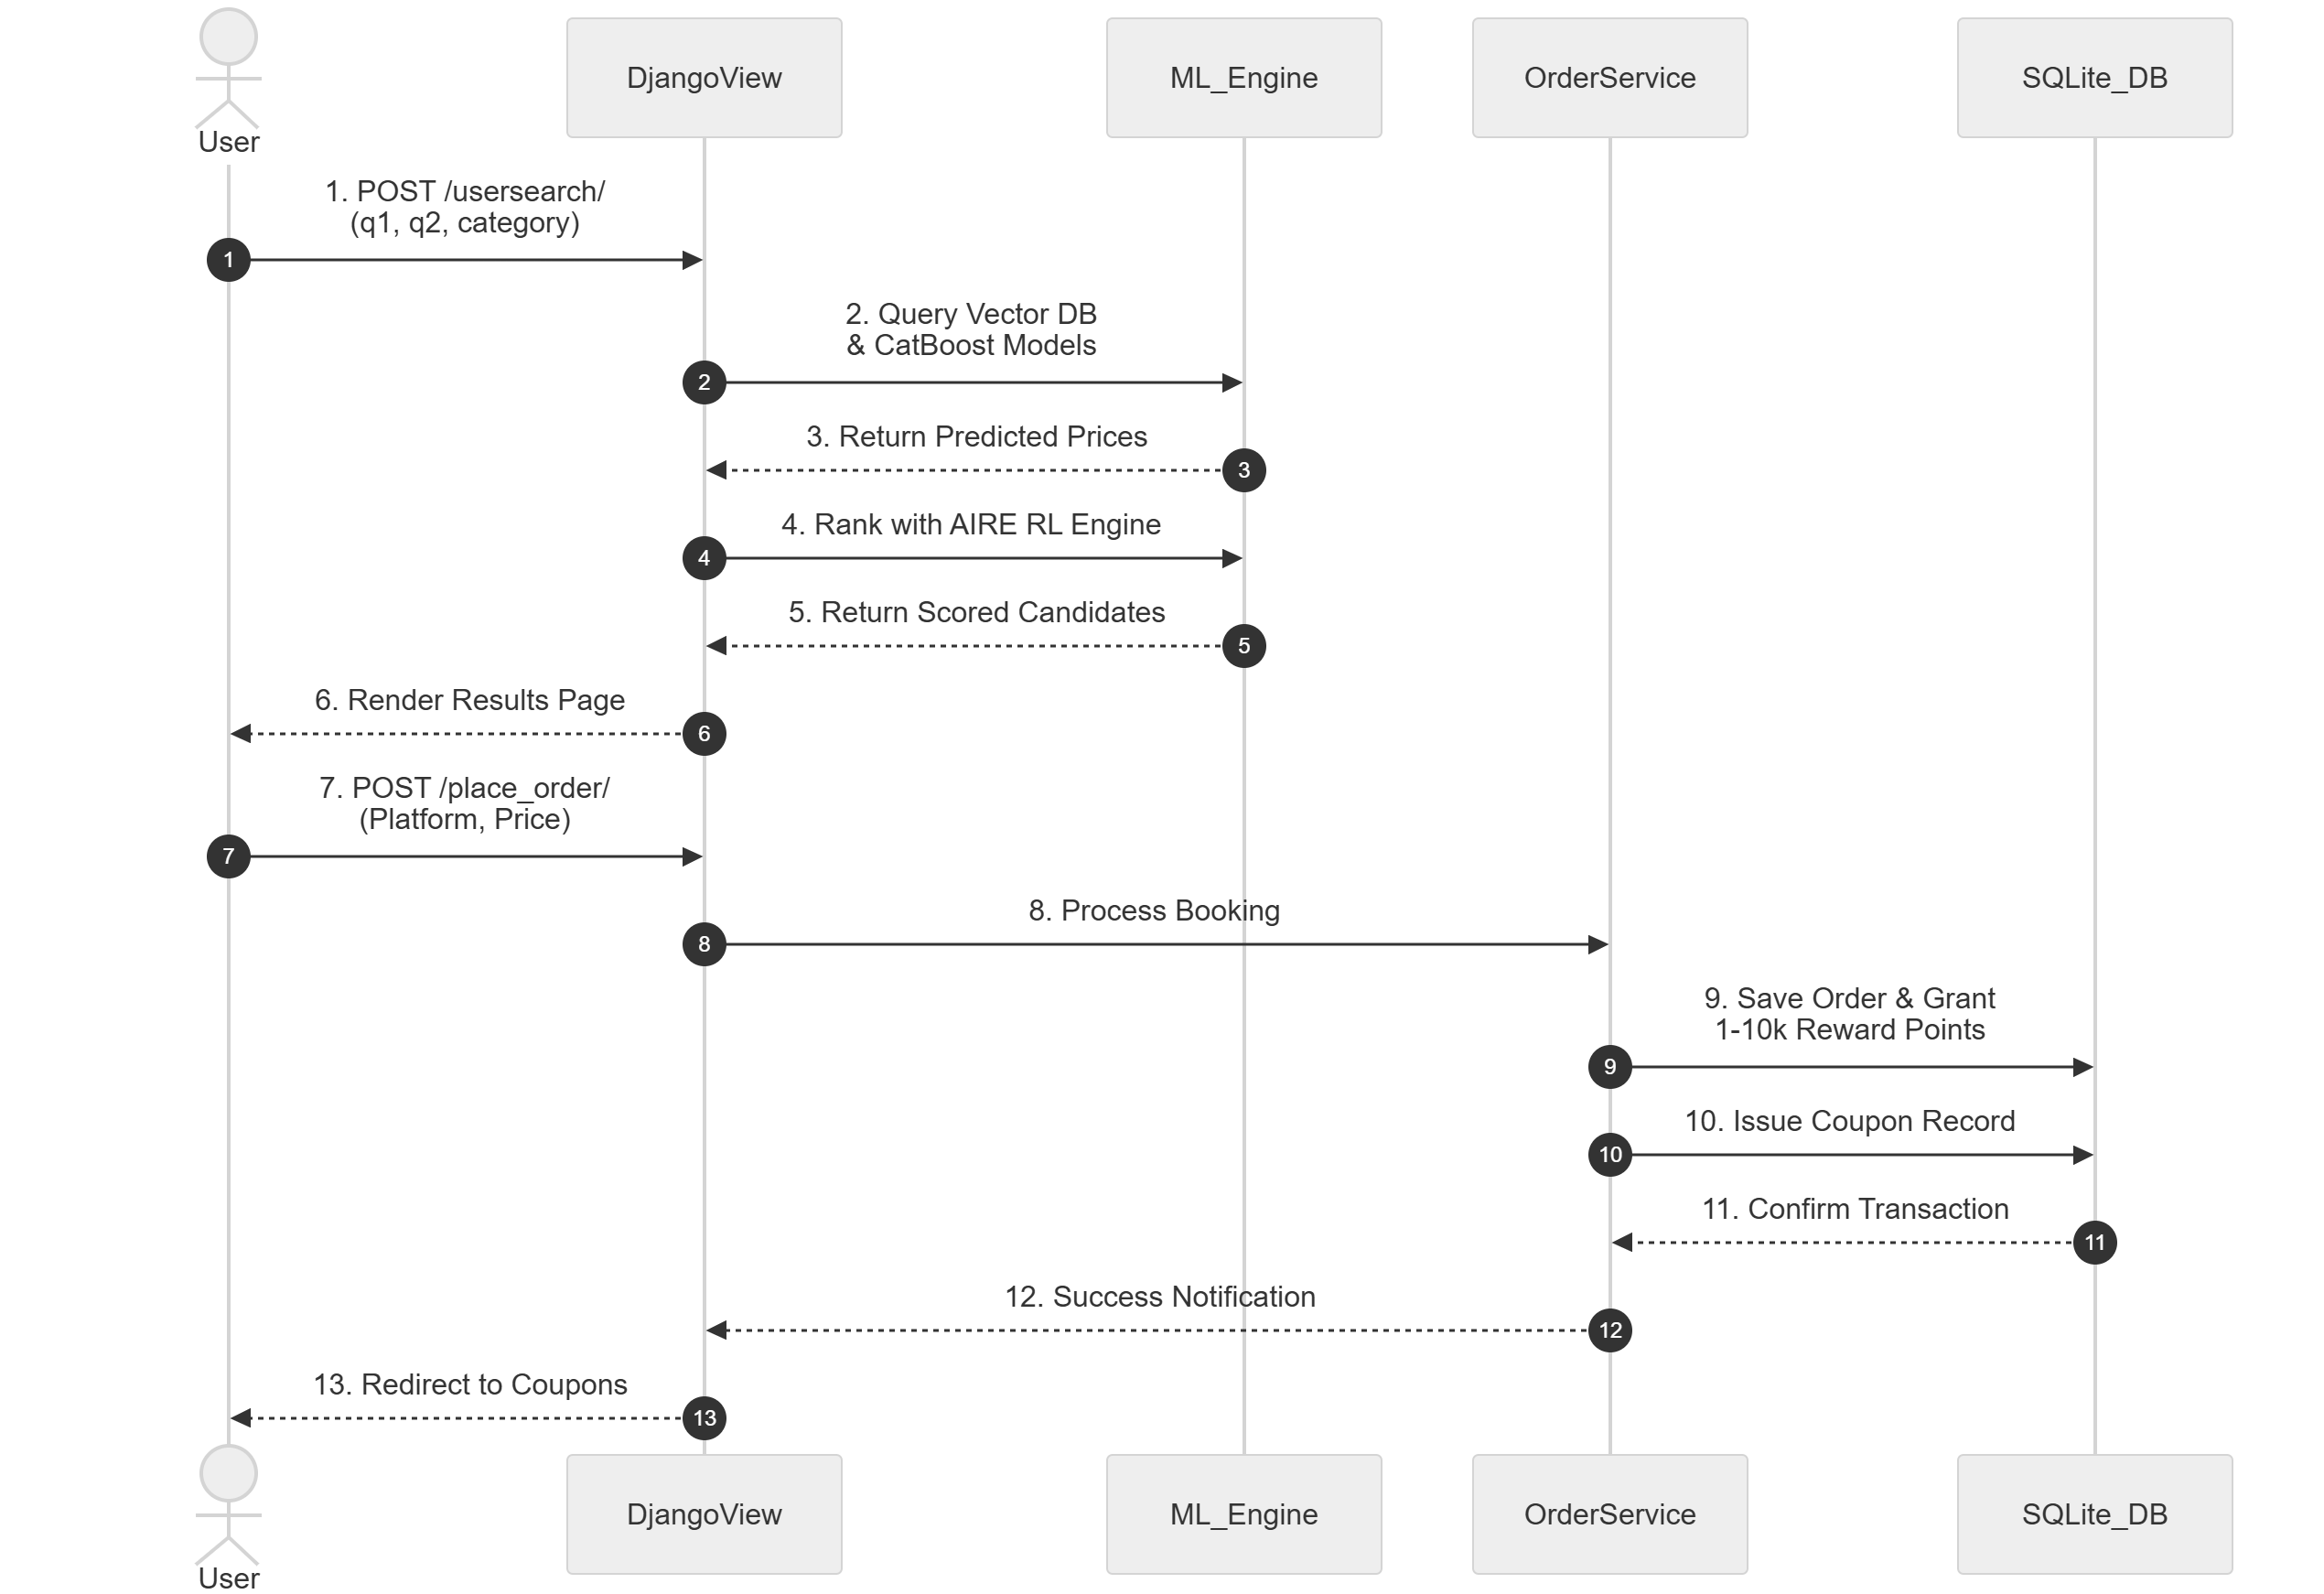
Key Flow:
- User submits search parameters $→$ View calls ChromaDB vector lookup and CatBoost ML inference.
- Candidates pass to AIRE RL engine for dynamic scoring $→$ View renders recommendation cards.
- User initiates booking $→$ Order Service updates database, awards points, and issues coupons.

Dataflow diagram
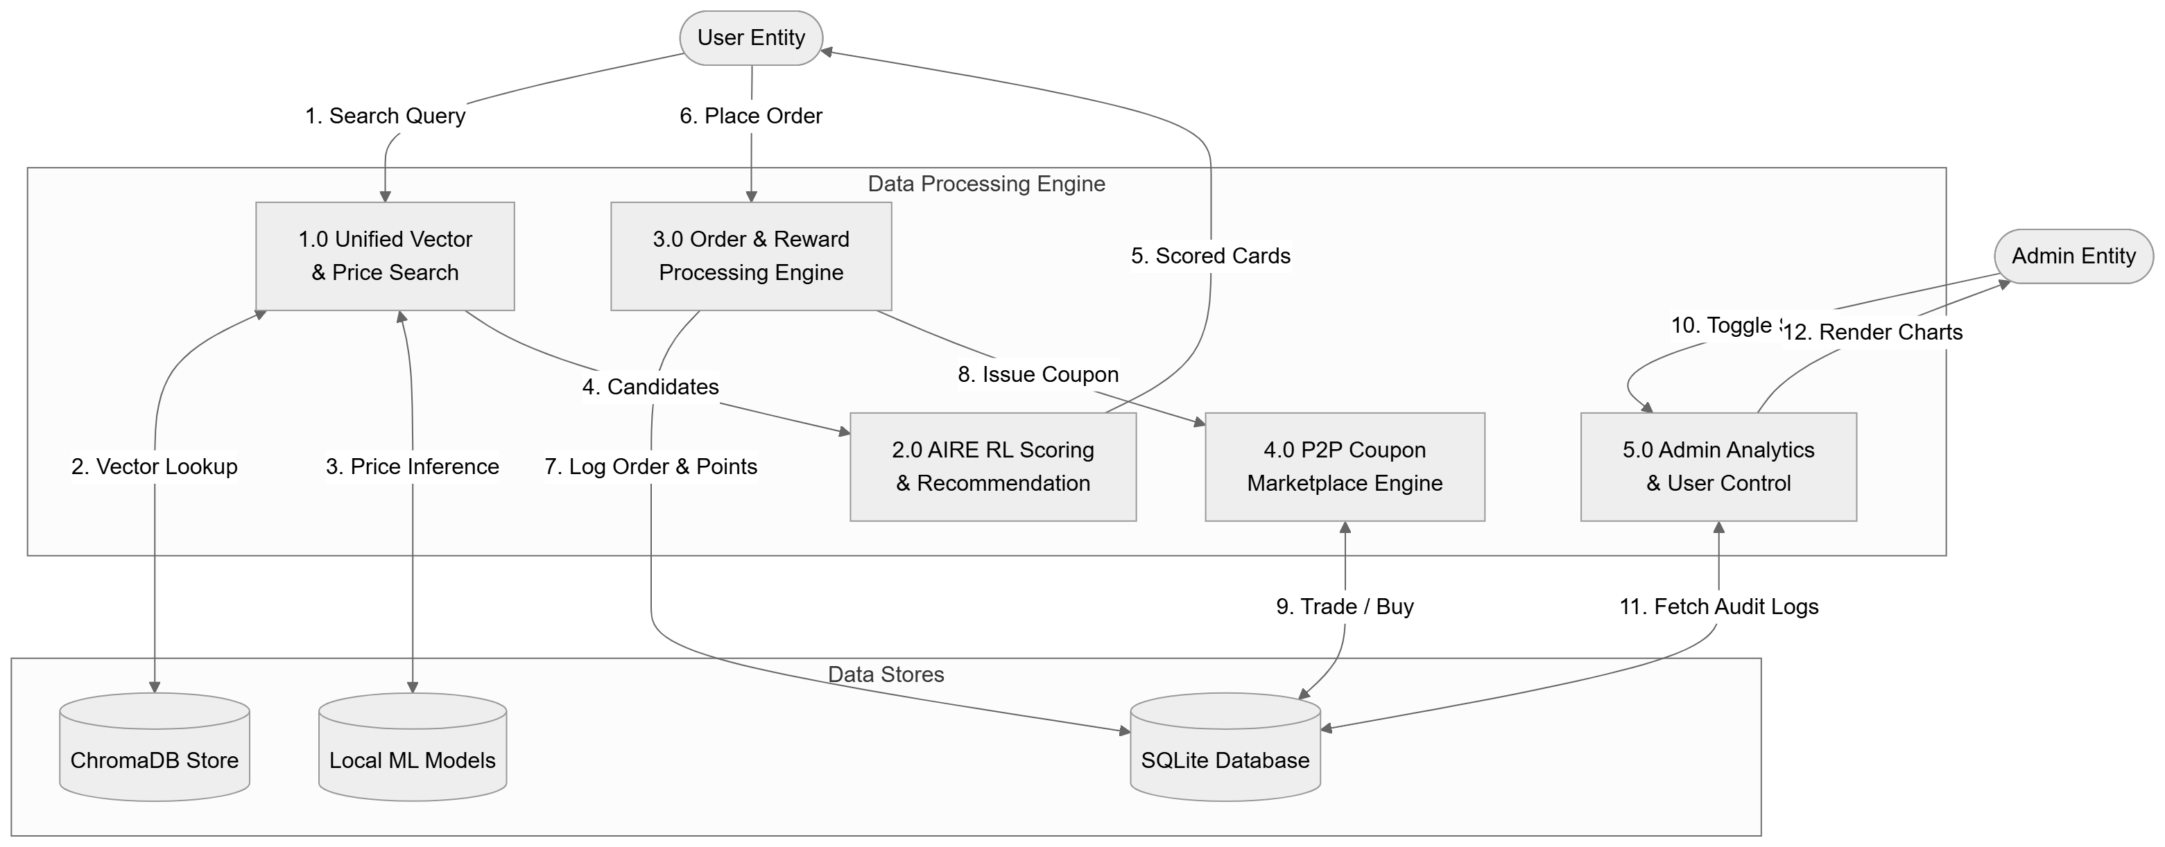
Key Flow:
- Search queries flow through ChromaDB and local ML models to return scored option cards.
- Order placements record data to SQLite DB and trigger reward/coupon generation processes.
- Admin interactions process status toggles and extract audit logs for chart rendering.

system architecture
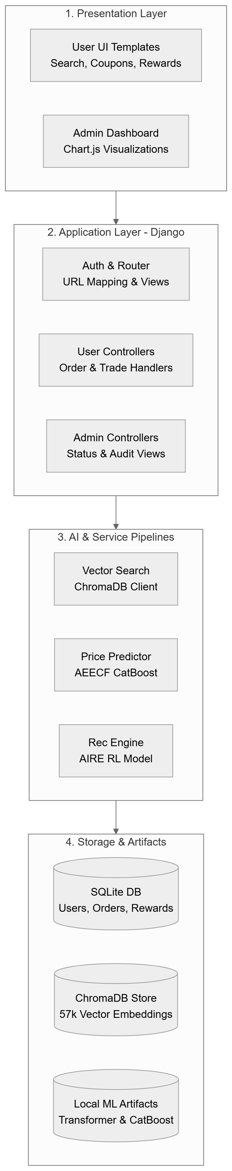
Key Flow:
- Presentation Layer communicates with the Django Application Layer via HTTP routes.
- Application views delegate computation to specialized AI and service pipelines.
- Service layer reads and writes to persistent storage (SQLite DB, ChromaDB, and local ML weight files).

model architecture
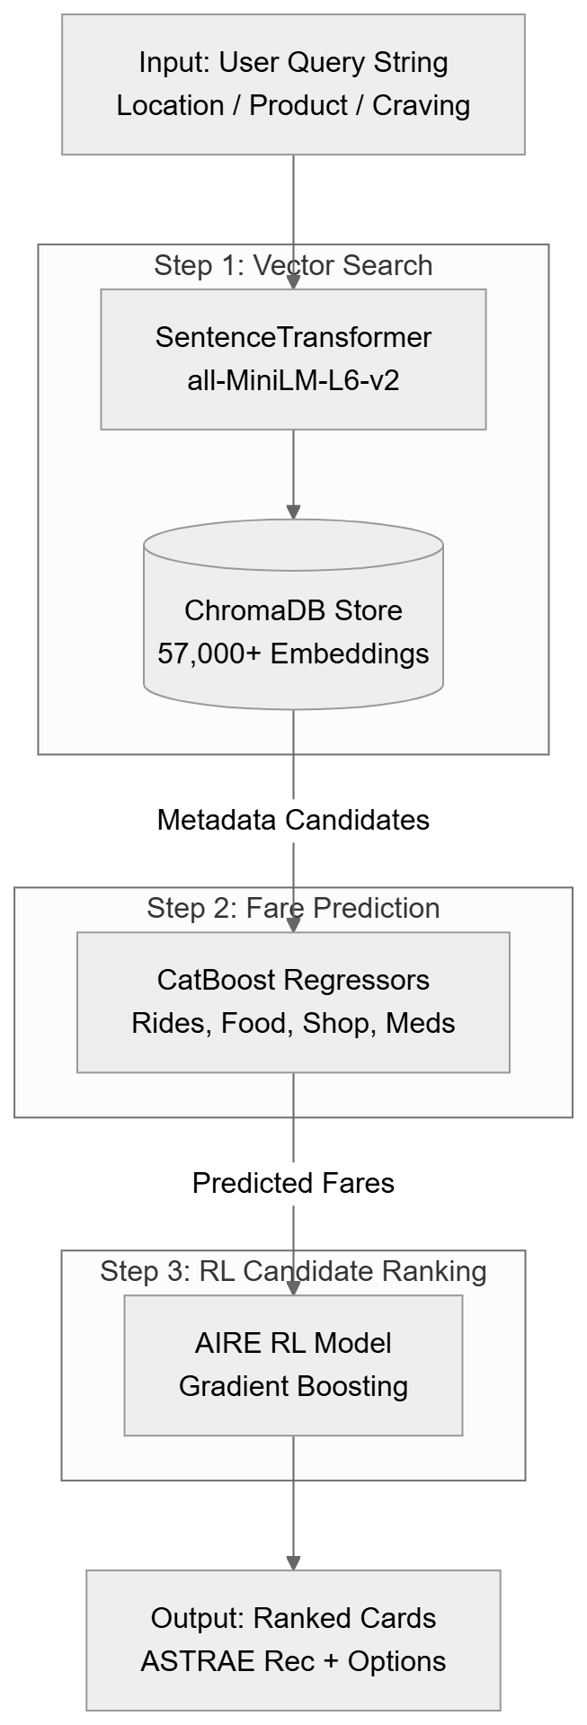
Key Flow:
- Step 1: Converts user text to embeddings using all-MiniLM-L6-v2 and fetches top matching records from ChromaDB.
- Step 2: AEECF CatBoost models evaluate candidate metadata to predict final prices across platforms.
- Step 3: AIRE RL Engine (Gradient Boosting) processes features to assign AIRE and Savings Scores for final ranking.

